CUSTOMER SEGMENTATION USING CLUSTERING
import pandas as pd
import matplotlib.pyplot as plt
from sklearn.cluster import KMeans
# Load dataset
df = pd.read_csv("C:\\CS proj(mini)\\Customer Personality Analysis Dataset.csv")
print(df.head())
Unnamed: 0 ID Year_Birth ... Z_CostContact Z_Revenue Response
0 0 5524 1957 ... 3.0 11.0 1.0
1 1 2174 1954 ... 3.0 11.0 0.0
2 2 4141 1965 ... 3.0 11.0 0.0
3 3 6182 1984 ... 3.0 11.0 0.0
4 4 5324 1981 ... 3.0 11.0 0.0
# Select features for customer segmentation
X = df[['Income', 'MntWines', 'MntMeatProducts', 'MntGoldProds']]
# Remove missing values
X = X.dropna()
# Apply K-Means Clustering
kmeans = KMeans(n_clusters=3, random_state=42, n_init=10)
X['Cluster'] = kmeans.fit_predict(X)
# Display first few records
print(X.head())
Income MntWines MntMeatProducts MntGoldProds Cluster
0 58138.0 635.0 546.0 88.0 0
1 46344.0 11.0 6.0 6.0 1
2 71613.0 426.0 127.0 42.0 0
3 26646.0 11.0 20.0 5.0 1
4 58293.0 173.0 118.0 15.0 0
# Number of customers in each cluster
print("\nCustomers in each Cluster:")
print(X['Cluster'].value_counts())
Customers in each Cluster:
Cluster
0 1154
1 1064
2 1
# Visualization
plt.figure(figsize=(8,6))
plt.scatter(X['Income'], X['MntWines'], c=X['Cluster'])
plt.xlabel("Income")
plt.ylabel("Wine Spending")
plt.title("Customer Segmentation Using K-Means Clustering")
plt.show()
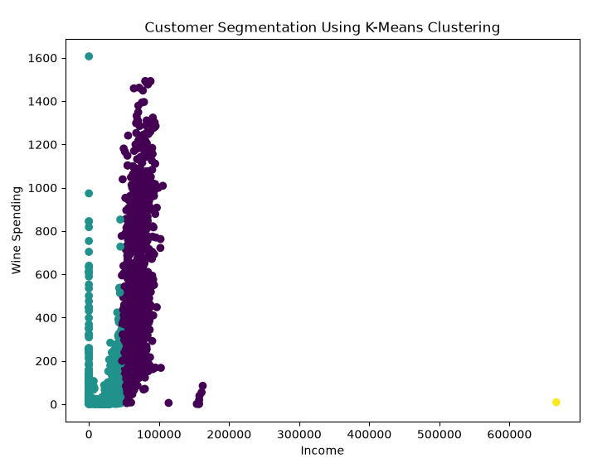
# Save output
X.to_csv("Customer_Segmentation_Output.csv", index=False)
print("\nCustomer Segmentation Completed Successfully!")
FINAL OUTPUT:
Customer Segmentation Completed Successfully!
DOCUMENTATION:
Customer Segmentation Using Clustering
1. Introduction
Customer Segmentation is the process of dividing customers into different groups based on their purchasing behavior and income. It helps businesses understand customer needs and create targeted marketing strategies. In this project, K-Means Clustering is used to group customers with similar characteristics.

2. Objective
- To analyze customer data.
- To group customers into different segments.
- To identify high-value and low-value customers.
- To improve marketing and business decision-making.

3. System Modules
Module 1: Data Collection
- Collect customer dataset from CSV files.
- Dataset contains customer income and spending information.
Module 2: Data Preprocessing
- Load dataset using Pandas.
- Handle missing values.
- Select required attributes.
Module 3: Feature Selection
Selected features:
- Income
- MntWines
- MntMeatProducts
- MntGoldProds
Module 4: Clustering Module
- Apply K-Means Clustering algorithm.
- Group customers into 3 clusters.
Module 5: Visualization Module
- Display customer segments using scatter plots.
- Analyze customer groups visually.
Module 6: Result Module
- Display cluster information.
- Save clustered customer data into a CSV file.

4. System Architecture
Customer Dataset
|
v
Data Preprocessing
|
v
Feature Selection
|
v
K-Means Clustering
|
v
Customer Segments
|
v
Visualization & Output

5. Methodology
Step 1: Data Collection
- Import customer dataset from CSV file.
Step 2: Data Preprocessing
- Remove missing values.
- Prepare data for clustering.
Step 3: Feature Selection
Choose important features:
- Income
- MntWines
- MntMeatProducts
- MntGoldProds
Step 4: K-Means Clustering
- Apply K-Means algorithm.
- Divide customers into 3 groups.
Step 5: Visualization
- Generate scatter plot.
- Display customer segments.
Step 6: Result Generation
- Save clustered data into output CSV file.

6. Algorithm
K-Means Clustering Algorithm
- Select the number of clusters (K).
- Initialize cluster centroids.
- Assign customers to the nearest centroid.
- Update centroid positions.
- Repeat until centroids do not change.
- Form final customer segments.

Conclusion
Customer Segmentation Using Clustering is an effective technique for analyzing customer behavior. By applying K-Means Clustering, customers are grouped into meaningful segments, enabling businesses to improve marketing strategies, customer satisfaction, and overall business performance.

